\

MENASP-CP GCRF
RESEARCH FUND
GUIDANCE NOTE

www.menasp.com

The MENASP Network’s Social policy and Conflict prevention (MENASP-CP) GCRF Research Fund sits within the Network’s Strengthening social welfare and security in the MENA region Research Programme which aims to advance scholarship and practice in security, social equality, and social protection in the MENA region.

This call is open to researchers and practitioners for research projects (between £10,000 - £50,000) or applied intervention and knowledge exchange projects (between £5,000 - £15,000). The fund encourages collaborations between UK and overseas collaborators focused on the MENA region, as well as individual applications. The countries of interest are the Arab countries of the South Mediterranean (Algeria, Egypt, Iraq, Jordan, Lebanon, Morocco, Palestine, Syria, and Tunisia) and comparative projects that involve other countries and or world regions are welcome.

The Fund also encourages interdisciplinary research that brings together the Arts and Humanities with the study of conflict prevention and social policy more widely.

Should you have any enquires regarding the call, please send an email to: menasp_network@bath.ac.uk quoting reference MENASPCP01/30 for Research Projects or MENASPCP02/30 for Applied Intervention and Knowledge Exchange projects in the subject.

Funded by

The MENASP-CP Fund
Calls for Research and Applied Intervention and Knowledge-Exchange Projects
2021-2022

Guidance Note
Applications process and due diligence checklist

Application Process
The image below shows the application process for this call including ethical review, safeguarding and due diligence. If you have any questions, please contact menasp_network@bath.ac.uk

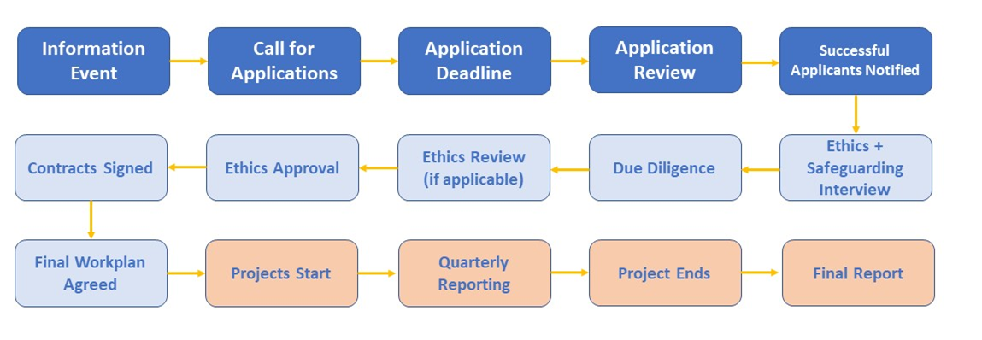

Due Diligence Checklist
For successful applications, funding will be subject to a due diligence process before a final funding contract is signed and mobilisation of the project can begin. While preparing your applications, please be aware of the below information that will be required during the due diligence stage.

- Please read the University of Bath’s Due Diligence process for grants with overseas partners: https://www.bath.ac.uk/guides/due-diligence-process-for-grants-with-overseas-partners/
- Every applicant organisation is required to provide a signed Heads of Terms document, which lays out their obligations should the proposal be successful.
- At the due diligence stage, we will require grantees to complete a ‘Partner Review Questionnaire’. Please do not fill this in at application stage, this is provided now for your reference and not for completion.
- Please read the below due diligence baseline for all potential grantees.

Due Diligence
- Ability to Deliver

Applicants should:
- be able to demonstrate in-house capacity in terms of staff and infrastructure to support and lead excellent research programmes;
- provide evidence of a commitment to maximising the wider impact and value of its research to the benefit of local economies and society;
- demonstrate commitment to the principle of open access publication, specifically in relation to projects and outputs funded via GCRF Network Plus awards (recognising institutions may not necessarily be signed up to equivalent UK recognised standards), costs for open access publishing led by LMIC partners may be included in applications for funding;
- have sufficient capacity to deliver research and/or other outputs that are appropriate to the wider aims of the Network Plus award and that can be meaningfully recorded and reported as such;
- demonstrate an ability and commitment to provide appropriate leadership and support to those staff (or partners) involved with funded research activity.

- Governance and Control

Applicants should:
- demonstrate good governance and control functions including policies and approaches to control risk and mitigate fraud and corruption;
- have satisfactory processes for preventing, detecting, reporting and responding to allegations of slavery, fraud, bribery and corruption;
- have satisfactory processes in place that meet Research Integrity and Ethics and Safeguarding requirements, including processes for dealing with allegations of misconduct;
- be subject to appropriate levels of independent audit;
- demonstrate an ability to support the effective collection, management, analysis, and dissemination of data.

For further guidance regarding research ethics please watch the following video: https://youtu.be/V69KkmfagZY

- Financial Stability

Applicants should:
- demonstrate that they are financially stable and have robust assurance around managing and accounting for grant funding;
- have a bank account that is in its legal name and that can be reconciled to the appropriate finance management system;
- have a basic finance management system that can be used to reconcile the bank account, to record all cash and payments ensuring that all transactions can be individually identified and provides suitable storage for supporting documentation;
- and, have satisfactory procedures in place for making payments for per diem, travel advances or review of receipts and subsequent reimbursement of expenses for approved official travel.

- Sub-contract Management

Where the Project lead / PI role on the project would involve sub-contracting to third parties, the applicants should:

- ensure there is a policy in place to sufficiently manage sub-contractors and address any associated financial or compliance risks.

